COA ASSIGNMENT No. 7
Aaditya Yuvaraj Hande
Div/Batch: A/A1
Roll No: 17
PRN: 202401040028

Title: Roots of quadratic equation

Result:
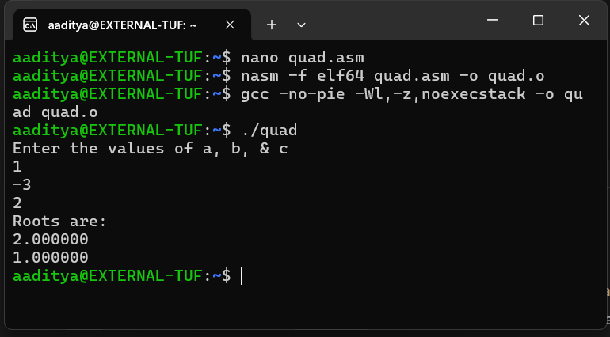
Code:
; quad.asm - Quadratic roots using x87 FPU (cleaned & formatted)
; NASM x86-64, SysV AMD64
; Assemble: nasm -f elf64 quad.asm -o quad.o
; Link: gcc -no-pie -Wl,-z,noexecstack -o quad quad.o
; Run: ./quad

section .note.GNU-stack,"",@progbits

extern printf, scanf

%macro write 2
push rbp
mov rax, 0 ; no XMM regs used for printing plain strings
mov rdi, %1 ; format / string
mov rsi, %2
call printf
pop rbp
%endmacro

%macro scan 2
push rbp
mov rax, 0 ; 0 XMM regs used for scanf
mov rdi, %1
mov rsi, %2
call scanf
pop rbp
%endmacro

%macro printfloat 2
push rbp
mov rax, 1 ; indicate 1 XMM register (for variadic printf)
mov rdi, %1 ; format string
movsd xmm0, %2 ; load the double (memory operand) into XMM0
call printf
pop rbp
%endmacro

section .data
fmt_in db "%lf",0
fmt_msg db "Enter the values of a, b, & c",10,0
fmt_roots db "Roots are:",10,0
fmt_root db "%lf",10,0
const4 dq 4.0
const2 dq 2.0

section .bss
a resq 1 ; double a
b resq 1 ; double b
c resq 1 ; double c
t1 resq 1 ; temp (b^2 or sqrt)
t2 resq 1 ; temp (-b)
t3 resq 1 ; temp (2a)
t4 resq 1 ; discriminant
r1 resq 1 ; root1
r2 resq 1 ; root2

section .text
global main
main:
; print prompt
write fmt_msg, 0

; read a
scan fmt_in, a

; read b
scan fmt_in, b

; read c
scan fmt_in, c

finit ; initialize x87 FPU

; ---------- compute b^2 ----------
fld qword [b] ; ST0 = b
fmul st0, st0 ; ST0 = b*b
fstp qword [t1] ; t1 = b^2 ; pop

; ---------- compute 4*a*c ----------
fld qword [a] ; ST0 = a
fld qword [c] ; ST0 = c, ST1 = a
fmulp st1, st0 ; ST0 = a*c (pop)
fld qword [const4] ; ST0 = 4.0, ST1 = a*c
fmulp st1, st0 ; ST0 = 4*a*c
fstp qword [t3] ; t3 = 4*a*c

; ---------- discriminant = b^2 - 4ac ----------
fld qword [t1] ; ST0 = b^2
fsub qword [t3] ; ST0 = b^2 - 4ac
fstp qword [t4] ; t4 = discriminant

; ---------- sqrt(|discriminant|) ----------
fld qword [t4] ; ST0 = discriminant
fabs ; ST0 = abs(discriminant)
fsqrt ; ST0 = sqrt(abs(discriminant))
fstp qword [t1] ; t1 = sqrt(|D|)

; ---------- compute -b ----------
fld qword [b] ; ST0 = b
fchs ; ST0 = -b
fstp qword [t2] ; t2 = -b

; ---------- compute 2a ----------
fld qword [a] ; ST0 = a
fld qword [const2] ; ST0 = 2.0, ST1 = a
fmulp st1, st0 ; ST0 = 2*a
fstp qword [t3] ; t3 = 2a

; ---------- compute root1 = (-b + sqrt)/ (2a) ----------
fld qword [t2] ; ST0 = -b
fld qword [t1] ; ST0 = sqrt, ST1 = -b
faddp st1, st0 ; ST0 = -b + sqrt
fdiv qword [t3] ; ST0 = (-b + sqrt) / (2a)
fstp qword [r1] ; r1 = root1

; ---------- compute root2 = (-b - sqrt)/ (2a) ----------
fld qword [t2] ; ST0 = -b
fld qword [t1] ; ST0 = sqrt, ST1 = -b
fchs ; ST0 = -sqrt
faddp st1, st0 ; ST0 = -b - sqrt
fdiv qword [t3] ; ST0 = (-b - sqrt) / (2a)
fstp qword [r2] ; r2 = root2

; ---------- print roots ----------
write fmt_roots, 0
printfloat fmt_root, qword [r1]
printfloat fmt_root, qword [r2]

xor rax, rax
ret

